References:

<https://hyperledger.github.io/composer/managing/managingindex.html>

Make sure the admin is logged in while a participant is added under admin(for which run ./reload.sh from inside your working directory).

* Adding a participant

composer participant add -p hlfv1 -n 'test-network' -i admin -s adminpw -d '{"$class":"org.acme.mynetwork.Trader","tradeId":"bob","firstName":" bob1","lastName":"dylan","company":"Capgemini"}'

composer participant add -p hlfv1 -n 'test-network' -i admin -s adminpw -d '{"$class":"org.acme.mynetwork.Trader","tradeId":"alice1","firstName":" alice","lastName":"vikander","company":"Igate"}'

* Issuing a new identity to a participant

A new identity can be issued to a participant using either the API, the command line, or by using ID cards in the Hyperledger Composer Playground. Once a new identity has been issued, the identity can then be used by the participant to interact with the business network in the context of that participant.

*composer network ping -p hlfv1 -n 'test-network' -i admin -s adminpw*

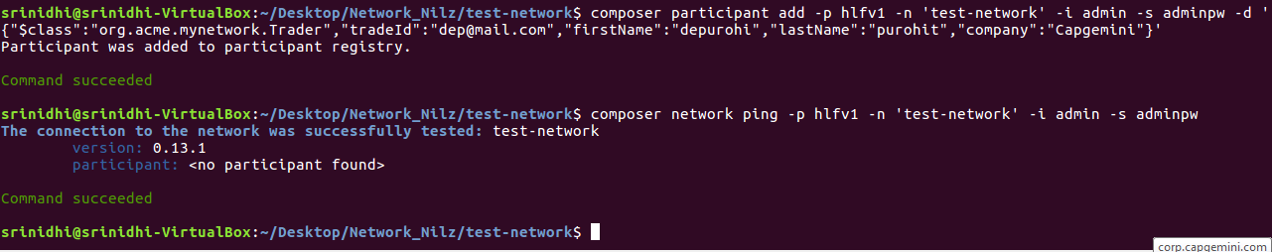

* Connect to the business network and issue a new identity to a participant

*composer identity issue -p hlfv1 -n 'test-network' -i admin -s adminpw -u trader1 -a "resource:org.acme.mynetwork.Trader#trader1"*



* Ping and check

*composer network ping -p hlfv1 -n 'test-network' -i testParticipantNilz -s gcUEVqaLjGlh*

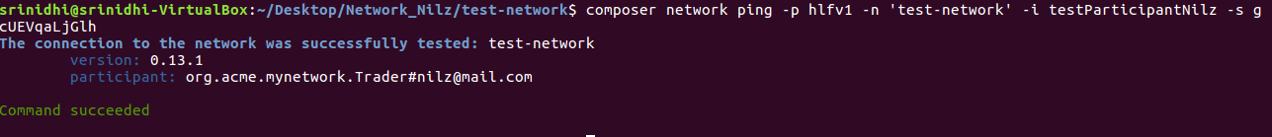

* List all identities

*composer identity list -p hlfv1 -n 'test-network' -i admin -s adminpw*

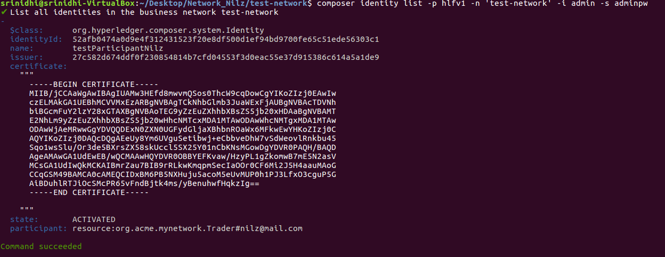

*composer identity revoke -p hlfv1 -n 'test-network' -i admin -s adminpw -u 52afb0474a0d9e4f312431523f20e8df500d1ef94bd9700fe65c51ede56303c1*

access control:

login as the admin user

composer-rest-server -p hlfv1 -n test-network -i admin -s adminpw -N never

first add the user to the network

then issue password(identity)

*composer identity issue -p hlfv1 -n 'test-network' -i admin -s adminpw -u trader1 -a "resource:org.acme.mynetwork.Trader#* *trader1"*

*